Department of Information Technology
Faculty of Computing
The Islamia University of Bahawalpur



Software Design Document
“ML Based Intelligent Career Counseling System Using Personality and Interest Analysis”

Submitted by
Noor Fatima
F22BINFT1M01066

Submitted to
Sir Karim Nawaz

Summery
This project develops an ML-based intelligent system designed to recommend suitable career paths based on an individual’s personality traits and interests. The system collects user responses through a structured questionnaire inspired by psychometric and interest-based assessments. Using machine learning algorithms, it analyzes personality patterns and correlates them with career success data to generate personalized career recommendations. The model learns from datasets mapping psychological profiles to professional roles, helping students and professionals make data-driven career decisions. The system will be deployed as an interface for accessibility.

Table of Content

1. Introduction 4
2. Application Architecture 4
2.1. Architectural Overview 4
2.2. Technology Stack 5
2.3. Request Flow 5
3. User Interface Design 5
3.1. Main Screens 5
3.2. UI Design Principles 6
4. Design Diagrams 6
4.1. System Workflow Diagram 6
4.2. Component Interaction Diagram 7
5. Machine Learning Design 7
5.1. Model Training 7
5.2. Prediction Flow 7
6. Security and Privacy Considerations 8
7. Conclusion 8

- Introduction

This Software Design Document (SDD) describes the system design derived from the Software Requirement Specification (SRS) for the ML Based Intelligent Career Counseling System. The document focuses on application architecture, data model schema, user interface design, and overall system workflow diagrams. The goal is to translate functional and non-functional requirements into a clear, implementable design.

- Application Architecture
  - Architectural Overview
The system follows a three-tier architecture:

- Presentation Layer (Frontend)

  - Web-based user interface
  - Collects personality and interest data through questionnaires
  - Displays career recommendations and confidence scores

- Application Layer (Backend / ML Engine)

  - Web-based user interface
  - Collects personality and interest data through questionnaires
  - Displays career recommendations and confidence scores

- Data Layer

  - Stores questionnaire definitions
  - Maintains training datasets mapping personality traits to careers
  - Optionally stores anonymized user responses and results

This layered approach ensures modularity, scalability, and ease of maintenance.

  - Technology Stack
- Frontend: HTML, CSS, JavaScript
- Backend: Python Framework (Flask or Django)
- Machine Learning: scikit-learn, pandas, NumPy

  - Request Flow
- User submits questionnaire
- Backend validates and preprocesses inputs
- ML model analyzes user profile
- Career recommendations are generated
- Results are sent back to the frontend

- User Interface Design
  - Main Screens
    - Home Page
- Introduction to the system
- Start assessment button
    - Questionnaire Page
- Multiple-choice and scale-based questions
- Progress indicator
- Submit button
    - Recommendation Page
- List of recommended careers
- Confidence score visualization
- Option to retake assessment

  - UI Design Principles
- Simple and intuitive layout
- Minimal technical terminology
- Mobile and desktop responsive
- Clear feedback on submission and results

- Design Diagrams

  - System Workflow Diagram

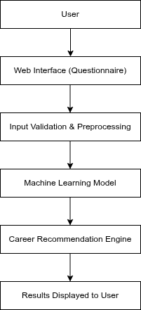

  - Component Interaction Diagram

- Machine Learning Design

  - Model Training
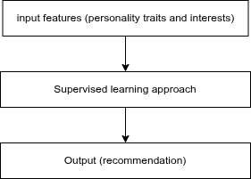

  - Prediction Flow
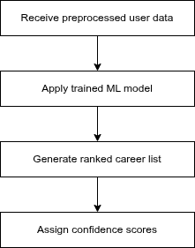

- Security and Privacy Considerations
- No sensitive personal data required
- Anonymized data handling
- Secure API endpoints
- Controlled access to training datasets

- Conclusion
This SDD provides a comprehensive design blueprint for implementing the ML Based Intelligent Career Counseling System. The proposed architecture ensures scalability, usability, and accuracy while maintaining simplicity for end users. The design supports future enhancements such as new questionnaires, advanced ML models, and expanded career datasets.

